The karma tool is an open source program that allows designers to integrate datasets based on an ontology schema and semantics. The University of South California developed it for integrating datasets of different form and format. To efficiently use the karma tools, knowledge of **Maven 3.0** and **Java 1.7** is required**.** Full installation and configuration can be obtained at the [Karma Website](https://github.com/usc-isi-i2/Web-Karma/wiki). The overall process for modelling and integrating the datasets are shown in Figure 6-1. The steps are illustrated bellow.

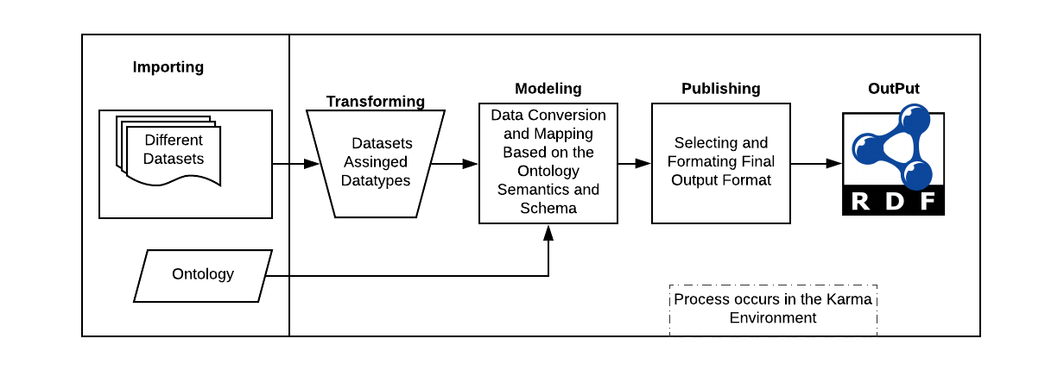

Figure 6‑1:: Overall Process for Modelling the Datasets in the Karma Environment

**Step 1: Importing Data**

The designed Citizen Science ontology is first loaded into the Karma environment to serve as the base model for modelling the different datasets. The implemented ontology is in an OWL file format. Using the import tab, Karma can import data from both structured and unstructured data. There were six different datasets imported into the karma environment. These datasets have no column in common but have some similar inherent properties captured in the ontology. Figure 6-2 shows an example of the data importing from Excel. Details on how to import different datasets from different platforms can be obtained at the karma [data import](https://github.com/usc-isi-i2/Web-Karma/wiki/Importing-Data) website. However, most of our datasets contain spatial information. Therefore, the [spatial data import](https://github.com/usc-isi-i2/Web-Karma/wiki/Working-with-geospatial-data) tab was also used.